1. Create a shell script to print the HTTP error code of guvi.in & print, the success/failure message based on the error code response
Bash script:
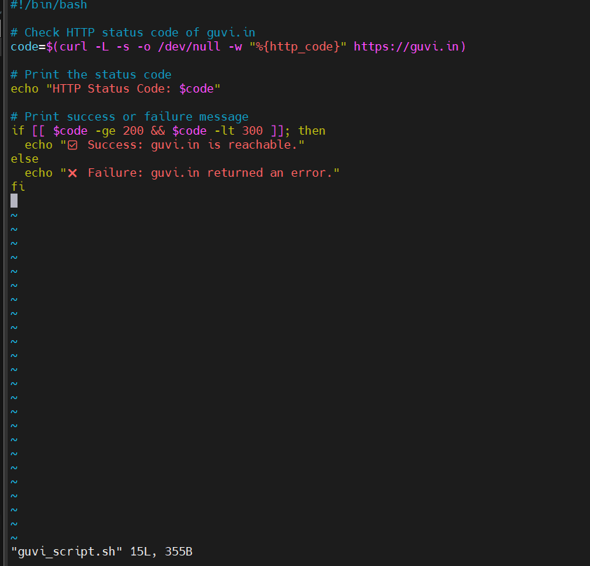
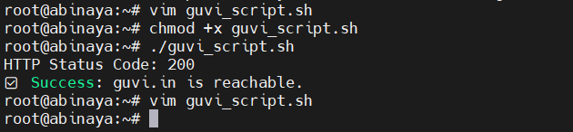
2.Create a shell script to print the HTTP error code of guvi.in & print, the success/failure message based on the error code response